1. Design DFA using simulator to accept the string start with a or b over the set {a,b}.

OUT PUT:

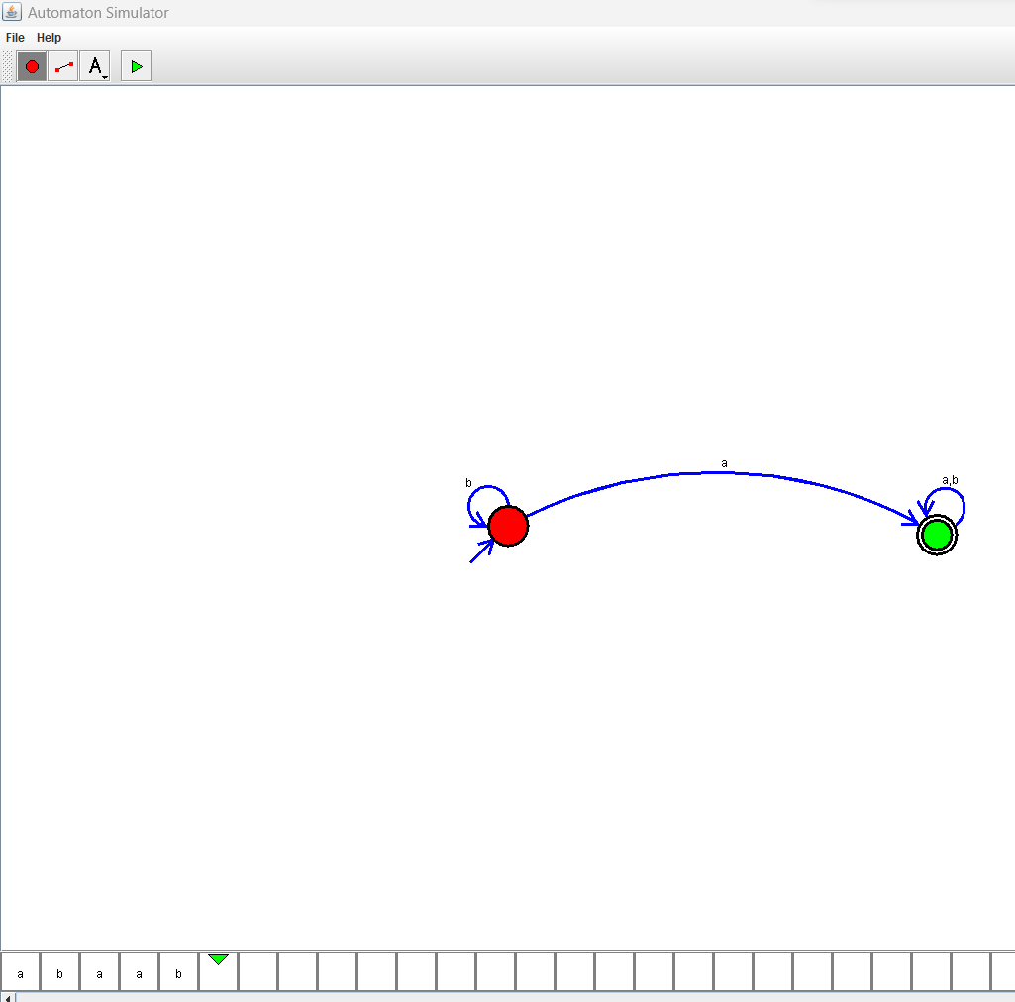

**RESULT**: THE DFA RUN SUCCESFULLY USING SIMULATOR BASED ON GIVEN STRINGS